Exp.No-9

9. Perform Rotation of an image to clockwise and counter clockwise direction.

Aim:
To rotate an image in clockwise and anticlockwise directions using OpenCV.

Procedure:
- Start the program.
- Import the OpenCV library.
- Read the input image.
- Rotate the image clockwise.
- Rotate the image anticlockwise.
- Display the original and rotated images.
- Save the rotated images.
- Stop the program.
Program:
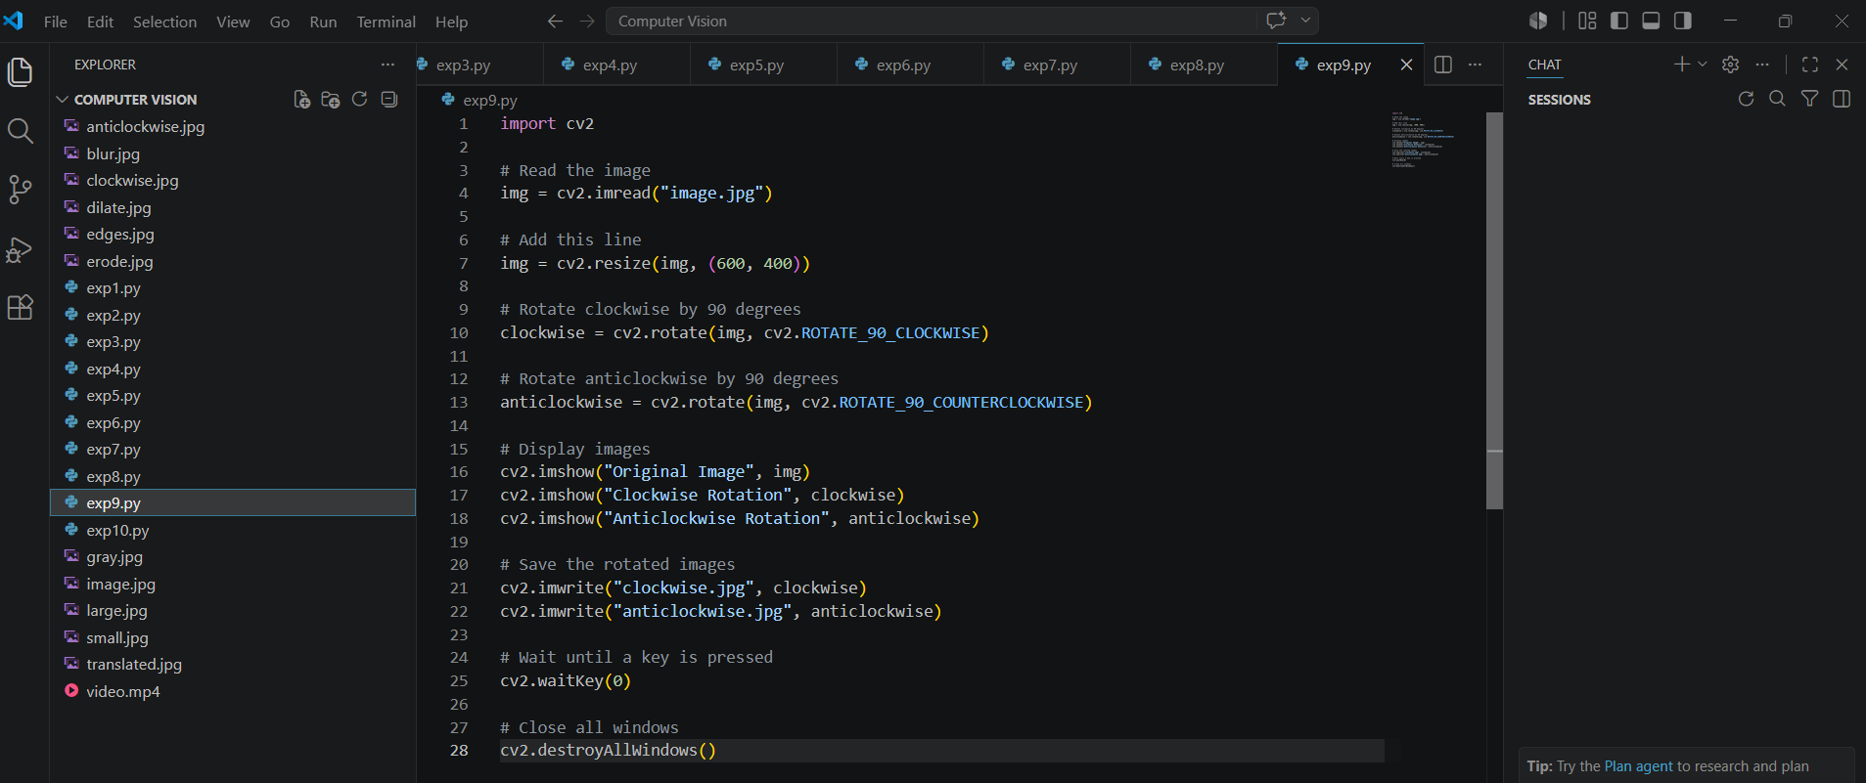

Input:
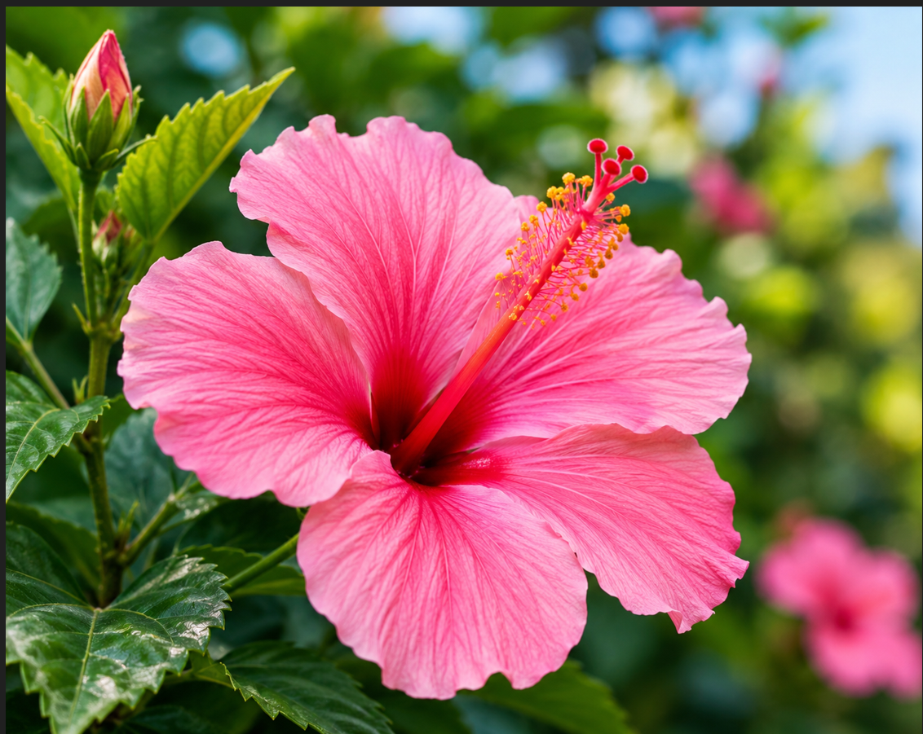

Output:
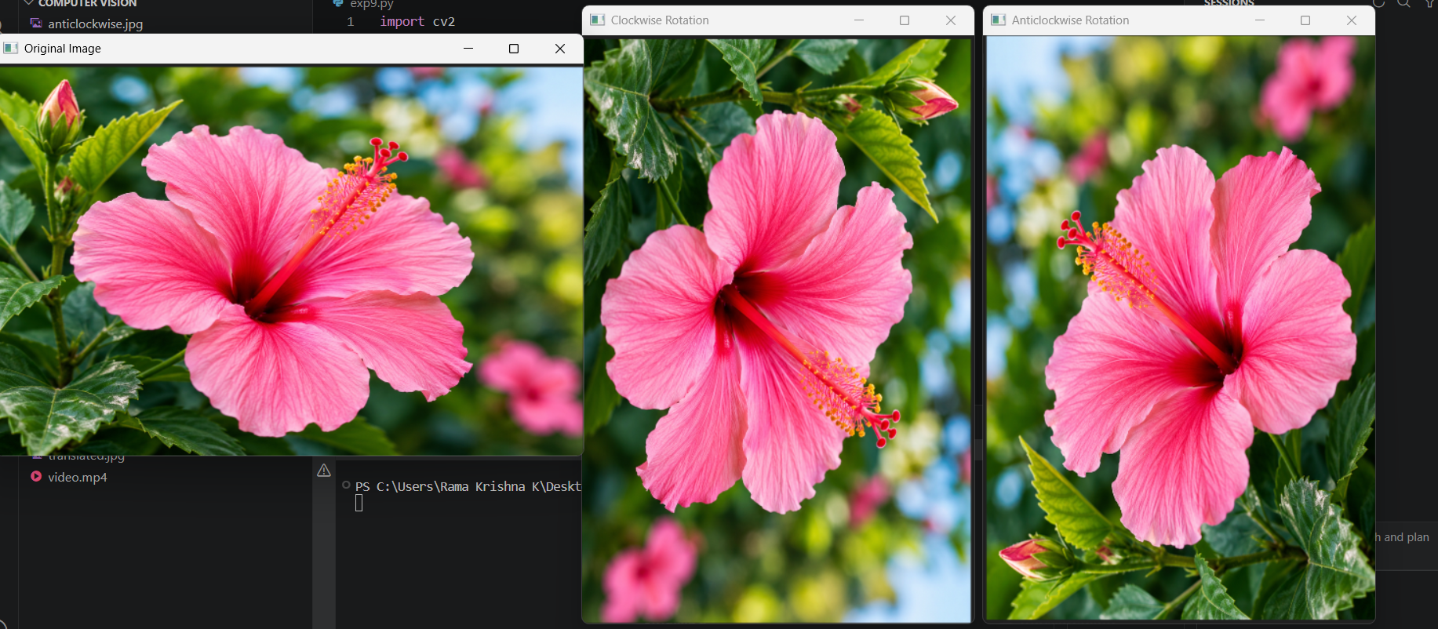
Result:
The input image was successfully rotated in both clockwise and anticlockwise directions.

